Computer Language Coding Concepts

Value Assignment in a Diagram
About the notation of assignment in general, see the article Assignment in a Diagram.

The principle of value assignment is explained in the article Value Assignment. This article demonstrates the expression of it in a diagram.

An assignment is a call to an assignment command, but the expression of an assignment call is given a more basic notation, like this:

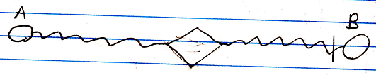

The fact, that the lines are wavy, expresses, that it is a value assignment. The access mark indicates the direction. The value of object A is assigned to object B.

If you must have a character symbol for a value assignment, that distinguishes it from the other assignment types, it is a mix of an = and the letter v, which stands for value.

This symbol is the identifier for value assignment. You can also express it as v=.

See also: Assignment in a Diagram, Value Assignment

Author & Copyright: Jan-Joost van Zon Date: May 24, 2008 – July 12, 2008 Location: Oosterhout, The Netherlands Status: Finished

